I search for my previous project about the text file. Combined with the previous experience in the JSON type, here is a simple architecture for the demo project. This project read the JSON file from top to the bottom line by line, get specific attributes from reach line, combine them to a list and display it.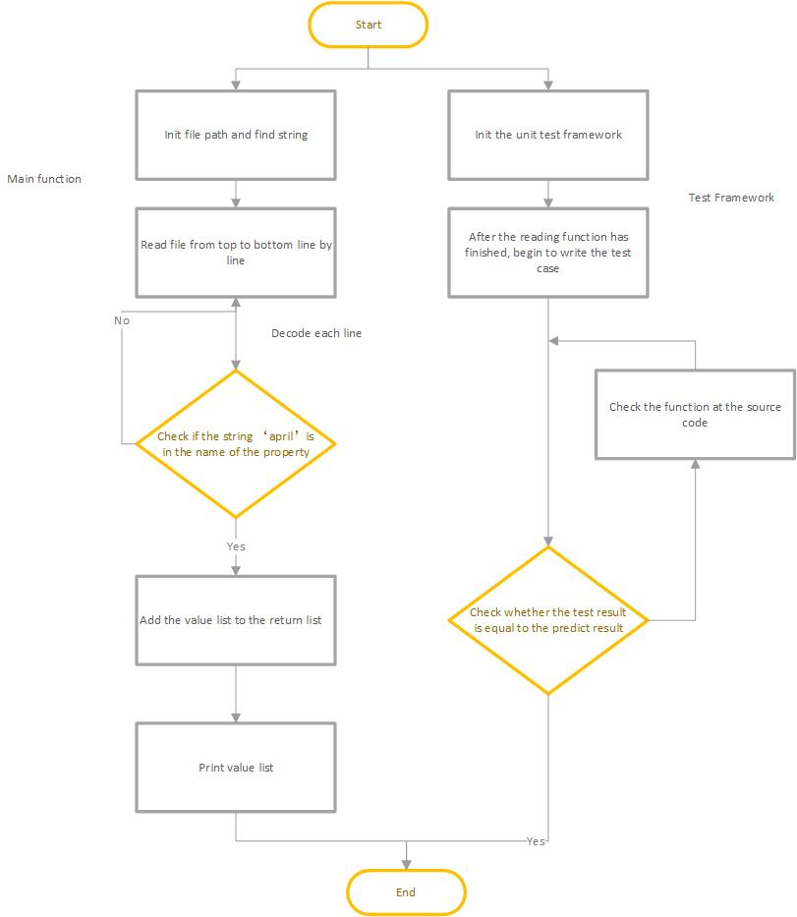

The following are the detail steps for the pipeline

1. The project contains two modules, Decode Json File and Test Case.
2. The Decode Json File module(readjson.py) will be initialized and read the JSON file from top to the bottom line by line. For each line, it will convert a string representation of the list to list. After getting the key value in each JSON string and turning it to lower case, the program will find the property which contains the specific string (such as ‘april’). If the return value is true, extend the list to the return list. Finally, it will print the fetch list.
3. In the Test Case module(test_get_specified_attributes.py), it will test the function at the Decode Json file module by Unittests Framework. If one test does not pass, we need to check the source code of the function. Open the statistics page for the test framework, and it displays the processing in the program when running each step. It will help us to increase the performance when it’s necessary.

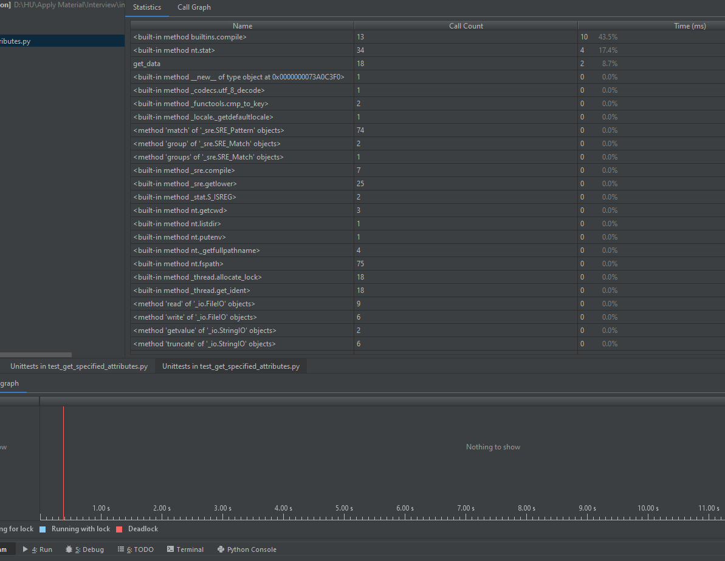

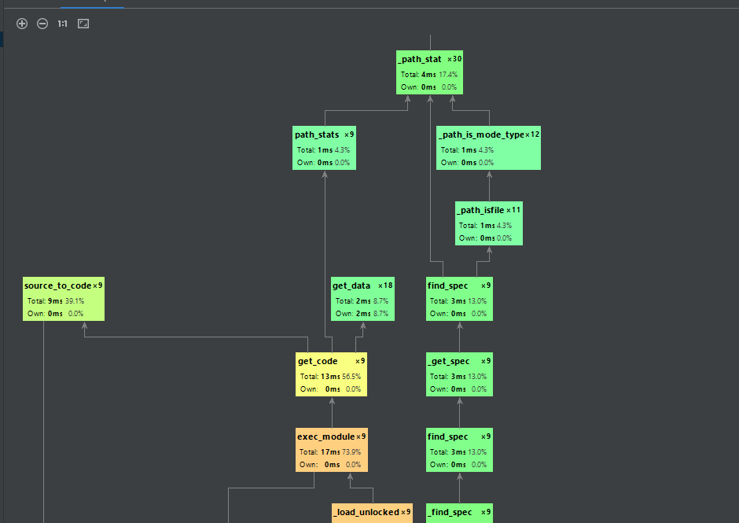

1. Limited the time and knowledge in the JSON file decoding, this project is simple, but contains the test case compare with the previous take-home task.
2. In the future, if the data file is enormous, the project will split the Decode Json File module to read the file module and decode module. The read file module will utilize multiple processing to generate several processes, read different start line and end line for a different process, deliver it to the message queue. Also, the decode module will fetch the JSON string from the message queue, transform the string to list, lower the name of the property, and find a specific property. If the return value is true, extend the list to the return list. Finally, it will print the fetch list and save it to a file or in the database.